Project Design Phase-II
Technology Stack (Architecture & Stack)

Date
Team ID
Project Name
Maximum Marks | 4 Marks
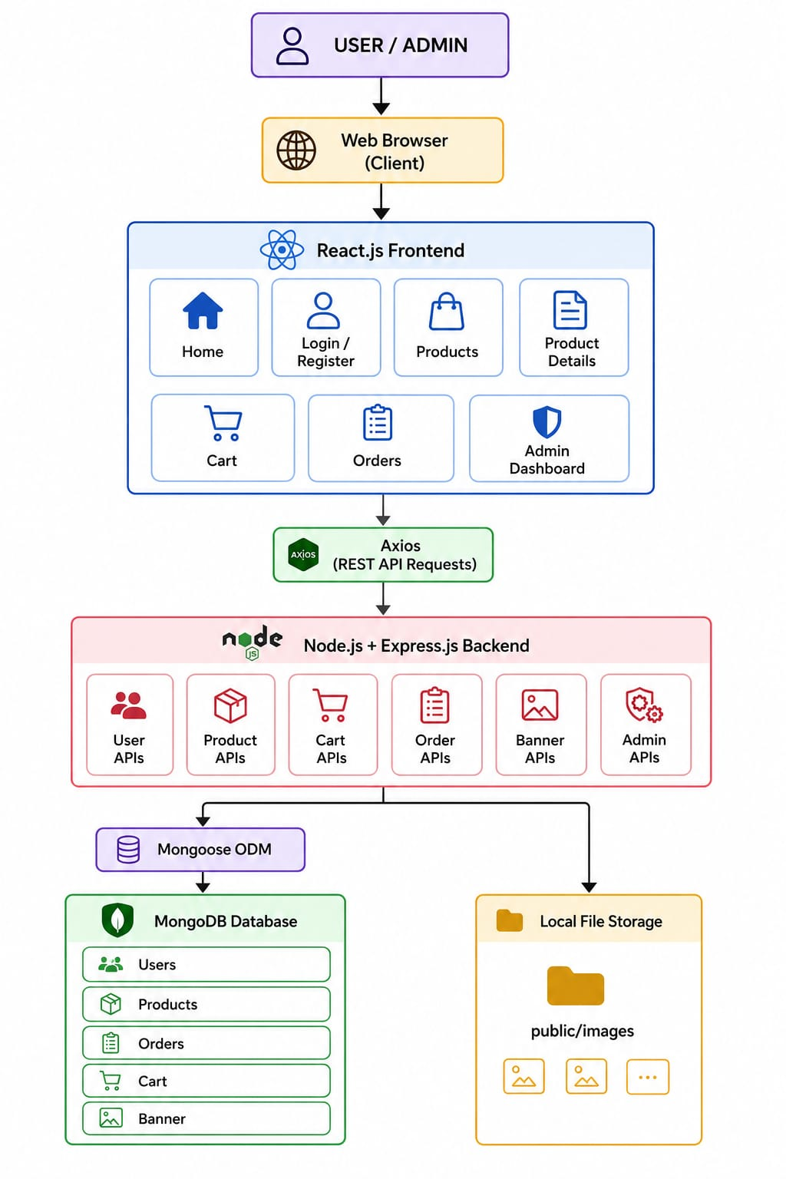
Technical Architecture Diagram:

Table-1 : Components & Technologies:
S.No | Component | Description | Technology
 | User Interface | Web-based e-commerce application for users and administrators to browse products, manage carts, place orders, and manage the system. | React.js (Vite), HTML5, CSS3, JavaScript
 | Application Logic-1 | Handles user registration, login, JWT authentication, profile management, and authorization. | Node.js, Express.js, JWT, bcrypt
 | Application Logic-2 | Manages products, categories, cart, orders, banner management, and admin operations through REST APIs. | Node.js, Express.js
 | Database | Stores application data including users, products, carts, orders, and banners. | MongoDB
 | Cloud Database | Not used in the current implementation. | N/A
 | File Storage | Stores product images and banner images locally. | Local File System (public/images)
 | External API-1 | Not used. | N/A
 | External API-2 | Not used. | N/A
 | Machine Learning Model | Not applicable to this project. | N/A
 | Infrastructure (Server / Cloud) | Application developed and tested in a local development environment using React frontend, Express backend, and MongoDB database. | Local Environment (React.js, Node.js, Express.js, MongoDB)

Table-2: Application Characteristics:
S.No | Characteristics | Description | Technology
 | Open Source Frameworks | Frontend and backend frameworks used for application development. | React.js(Vite), Express.js, Node.js
 | Security Implementations | Secure authentication using JWT tokens, password hashing using bcrypt, protected routes, and REST API validation. | JWT, bcrypt, Express Middleware
 | Scalable Architecture | Three-tier architecture separating presentation layer, application layer, and database layer for better maintainability and scalability. | MERN Architecture
 | Availability | The application is available in the local development environment where the React frontend communicates with the Express backend and MongoDB database. | React.js(Vite), Express.js, MongoDB
 | Performance | RESTful APIs, optimized MongoDB queries, React component rendering, and Axios-based asynchronous communication improve application performance. | React.js(Vite), Axios, MongoDB

References:
https://vite.dev/
https://react.dev/
https://nodejs.org/docs/latest/api/
https://expressjs.com/
https://www.mongodb.com/docs/

